**Handson 4**

1. Make some changes in the code of the project. Go to Team explorer select changes and add commit. Click on sync and select push.

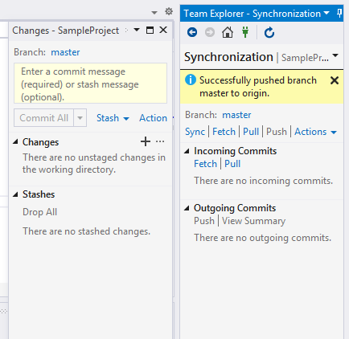

1. Go to pipe line to check the build has started again.

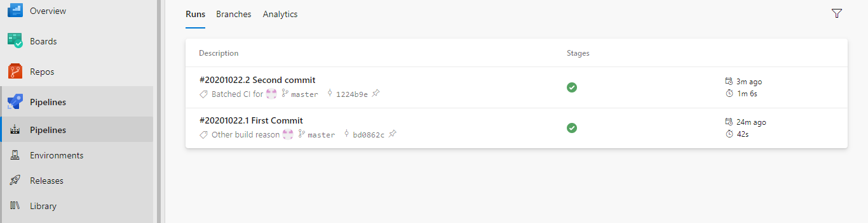

1. Another release is created

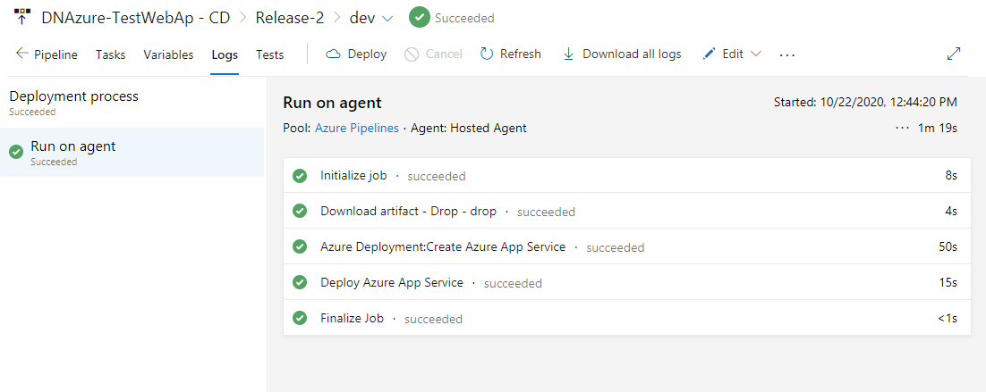

1. Check the api output to see the changes

